**PROGRAM 3**

**Aim**

To write a Python program that solves the **Water Jug Problem** using state-space search, where the goal is to measure the desired amount of water using two jugs of given capacities.

**Algorithm**

1. Start with two jugs of capacities jug1 and jug2, initially empty.
2. Represent a state as (x, y) where x is the amount of water in jug1 and y is the amount in jug2.
3. From any state, possible moves are:
   * Fill jug1
   * Fill jug2
   * Empty jug1
   * Empty jug2
   * Pour water from jug1 → jug2
   * Pour water from jug2 → jug1
4. Use BFS to explore all possible states until the target amount is reached in either jug.
5. If target is found, print the sequence of steps (path).
6. Stop.

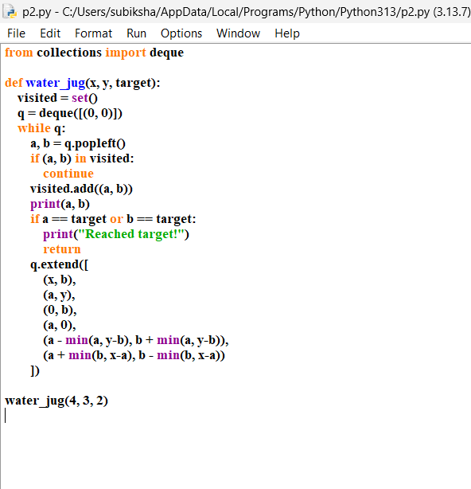

Output :

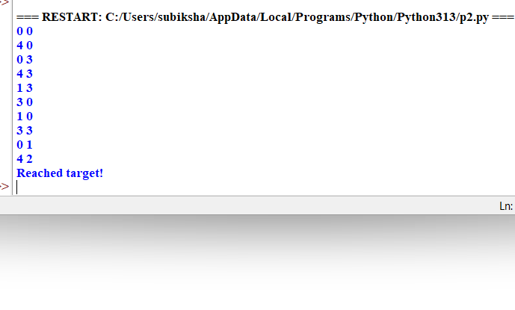

Result :

Thus, the program successfully solves the Water Jug Problem using BFS.